Go to [Pipelines - Runs for pscad-v5-4state-model-v1 (azure.com)](https://dev.azure.com/AEMO-Cloud/NationalConnections/_build?definitionId=1219&view=runs)

Click Run pipeline-> Select Case->247

Step 1: Retrieve VM target Meta Data - Set Firewall Rules

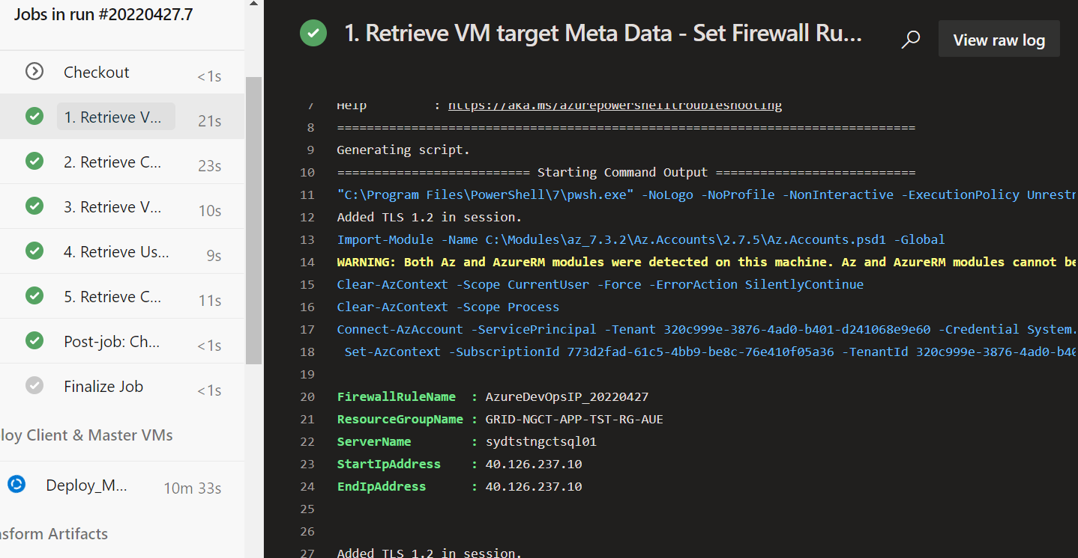

Step 2: Retrieve Case Data – Query

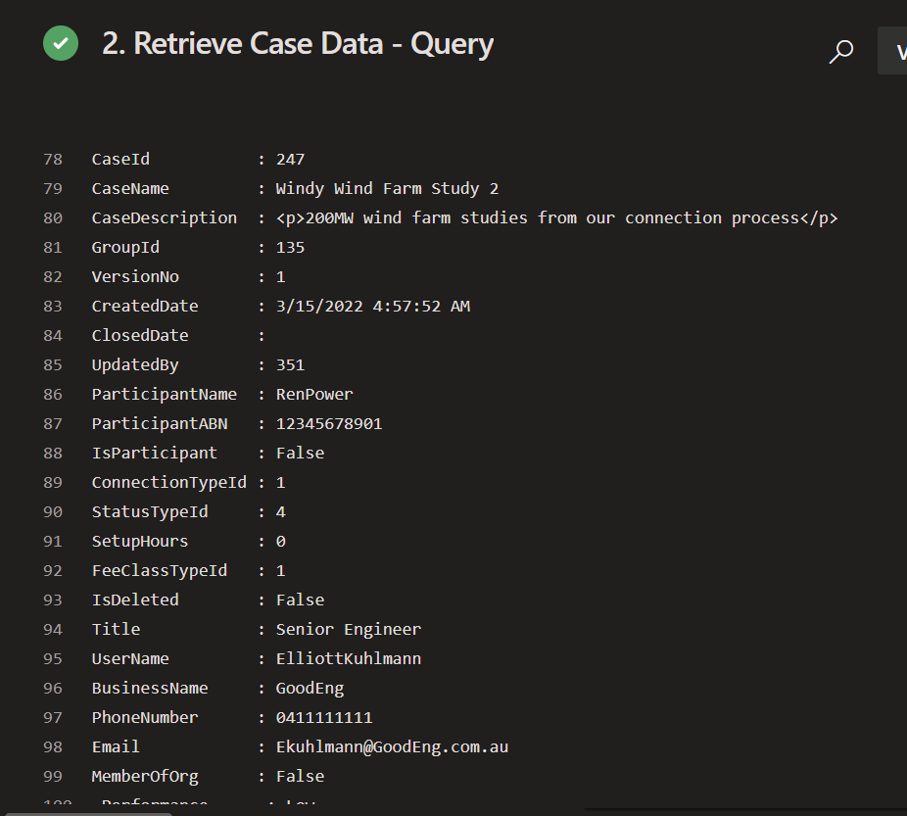

Step 3: Retrieve VM target Meta Data – Query

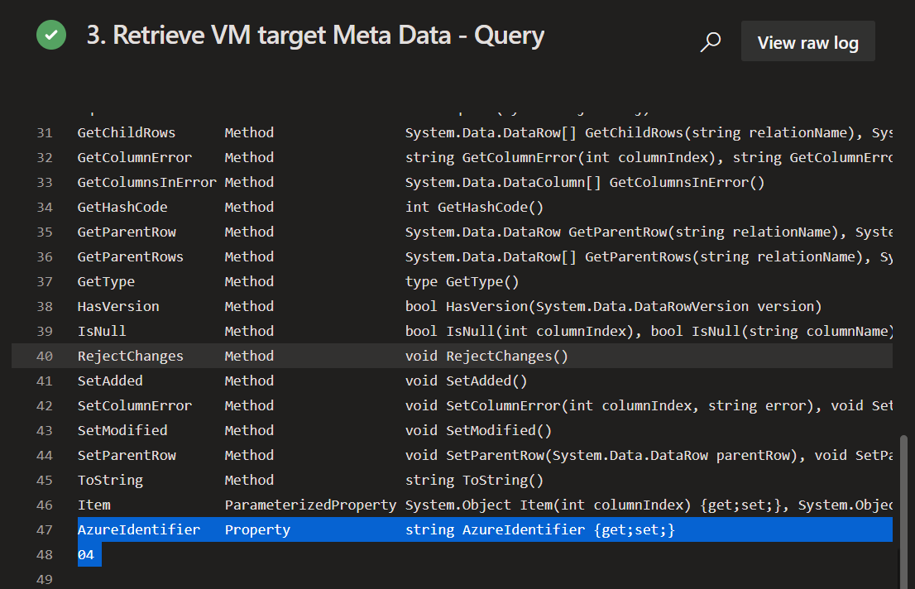

4. Retrieve User target Meta Data – Query List of associated user emails (usernames)

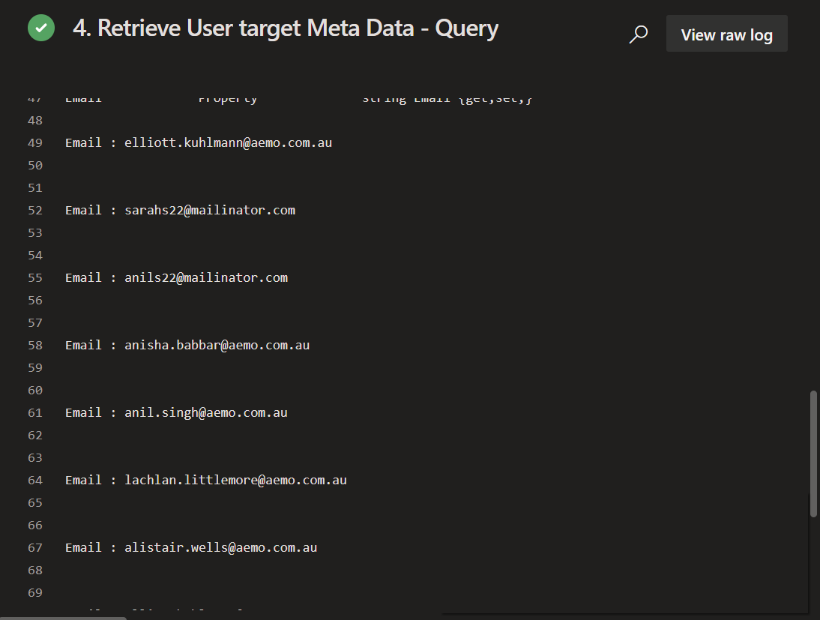

5. Retrieve Company target Meta Data – Query

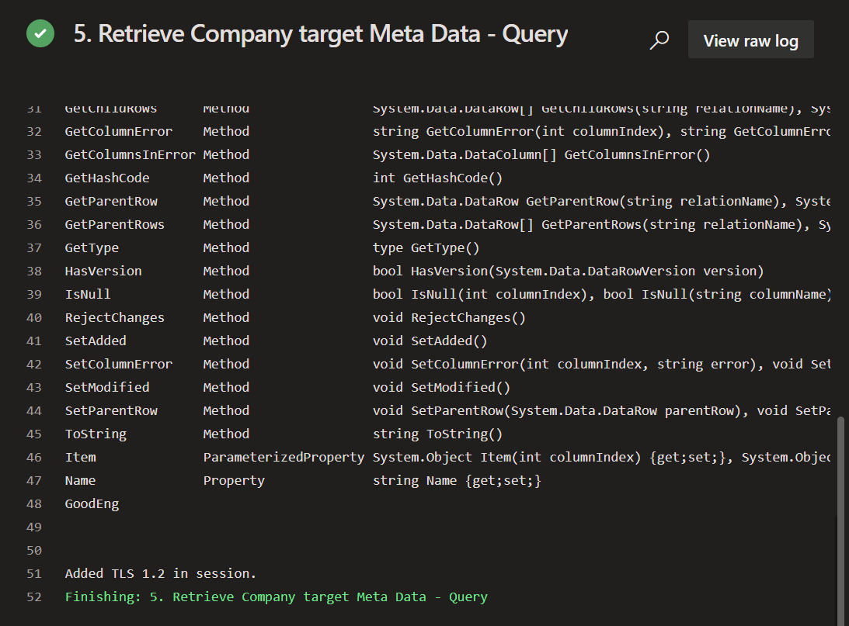

**Deploy_Master_And_Client_VM**

Step 6: Deploy Master VM (install visualstudio, fortran, pscad)

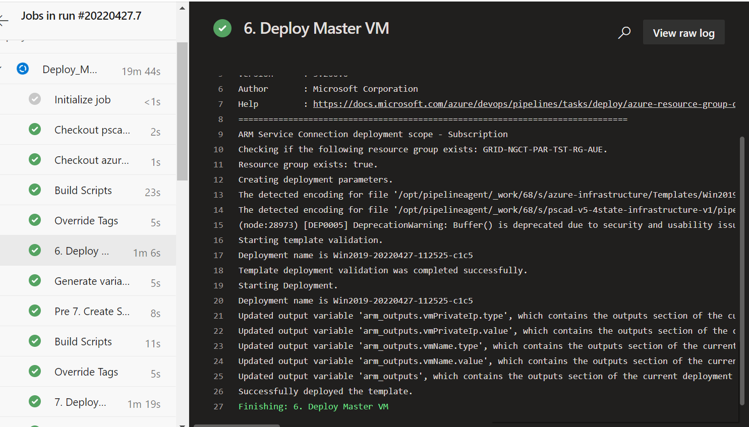

Precheck if par04 storage container already exists

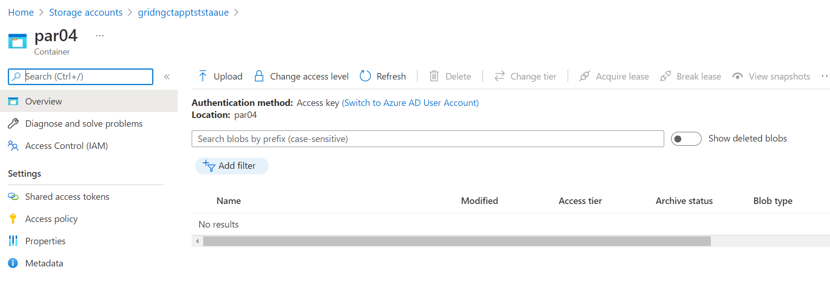

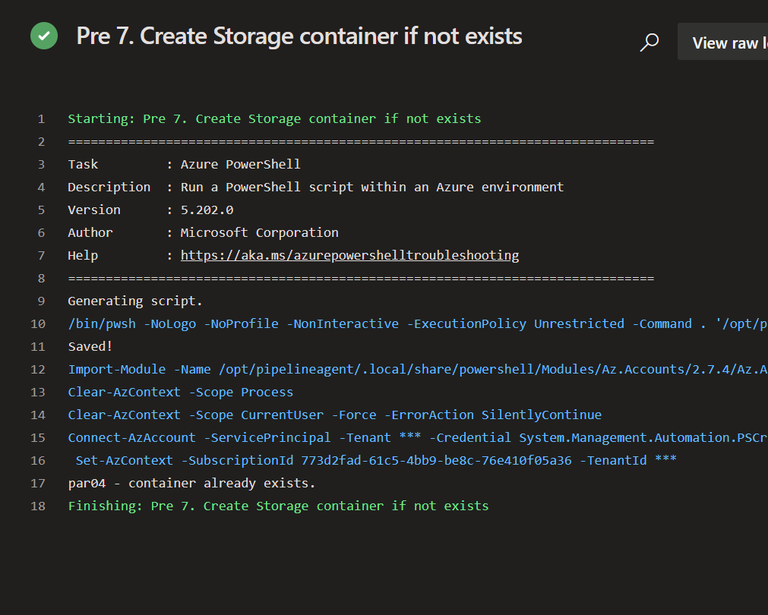

7. Deploy Client VM (install visualstudio, fortran, pscad)

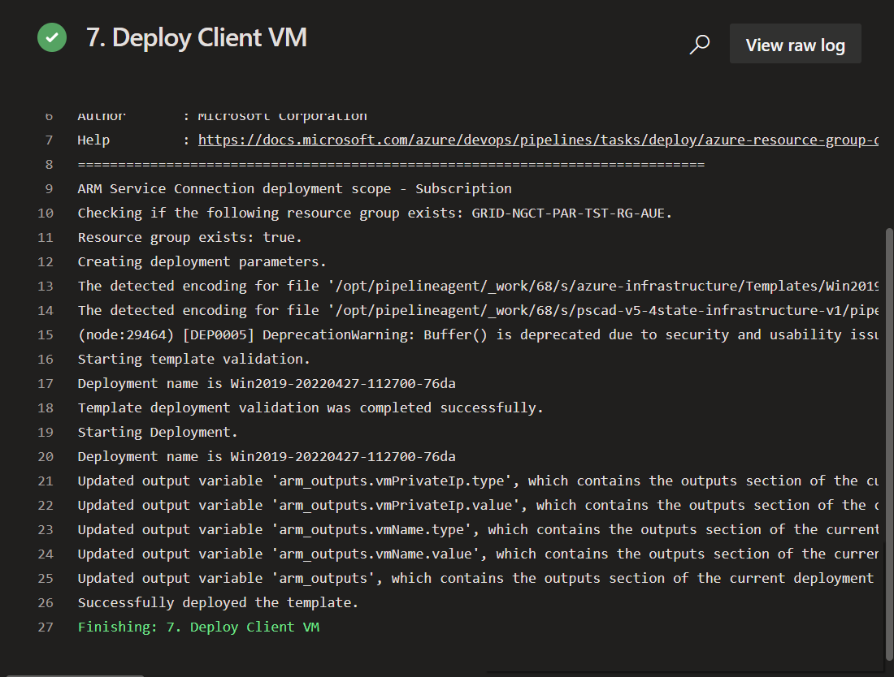

Install pscad and dependencies

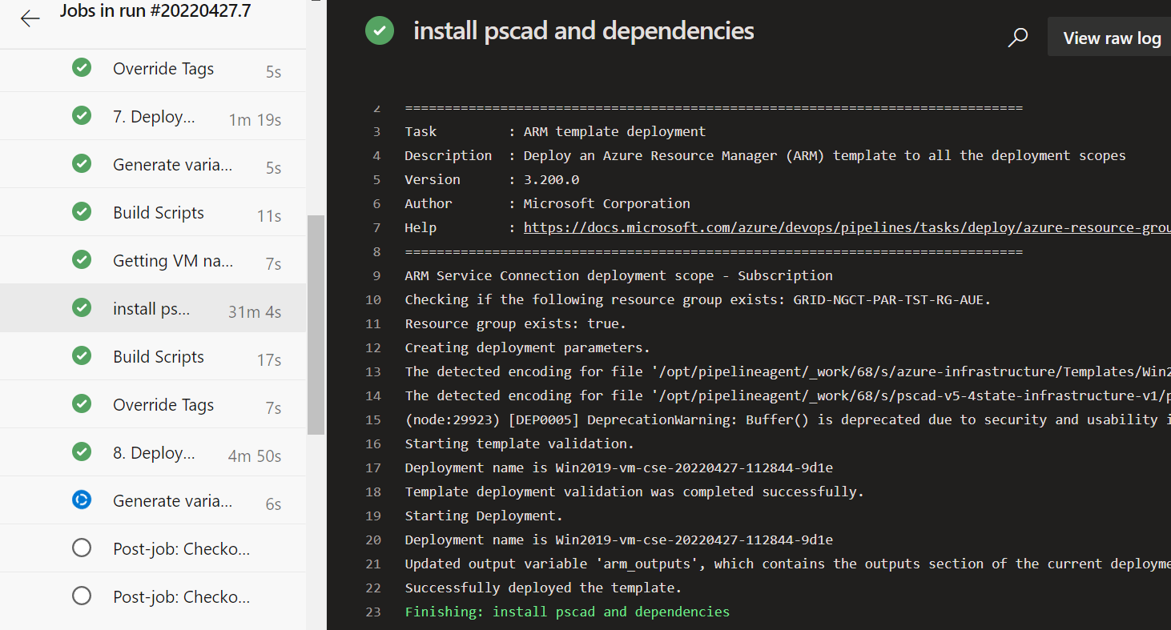

8. Deploy Jumpbox VM (install myrtille)

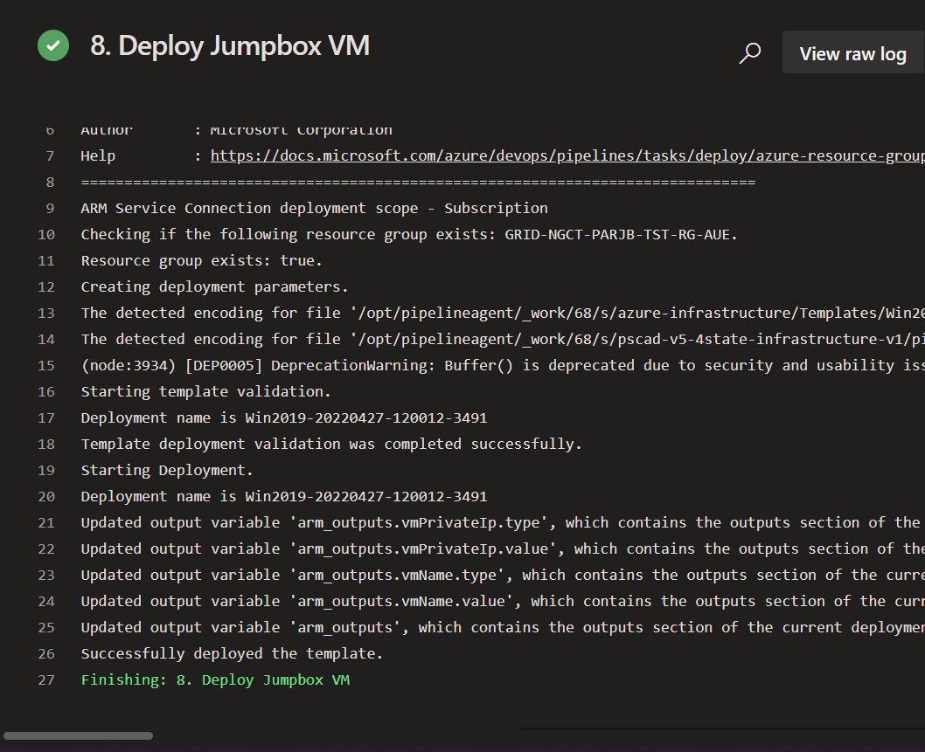

Client and Master

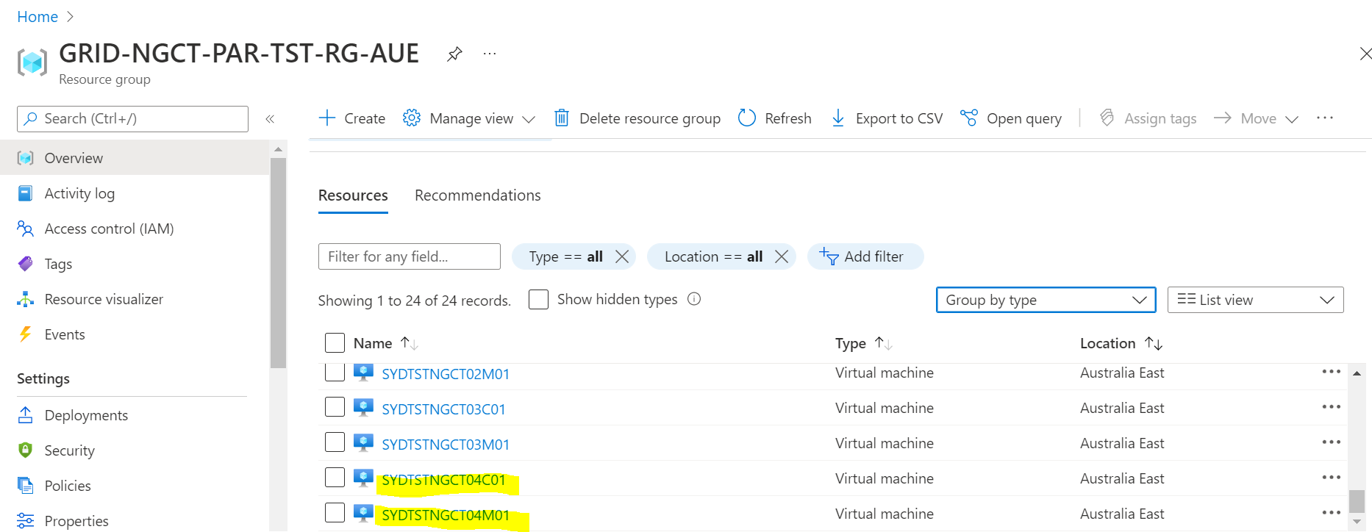

Jump server

**Transform_Model**

**Step 9:**

Transform PSCAD IP Config

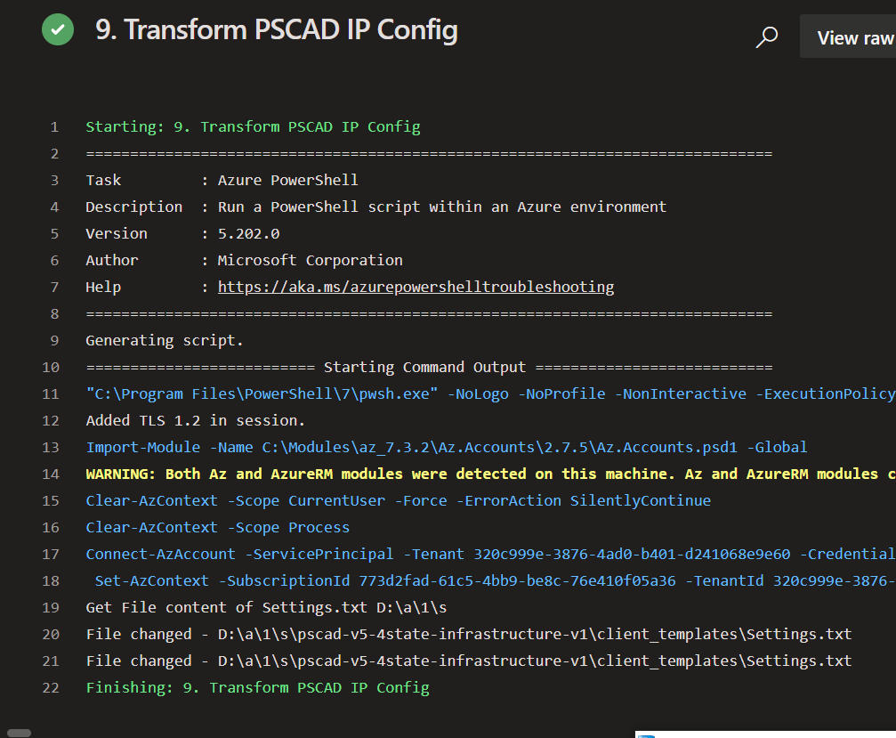

10. Transform Export Results Script 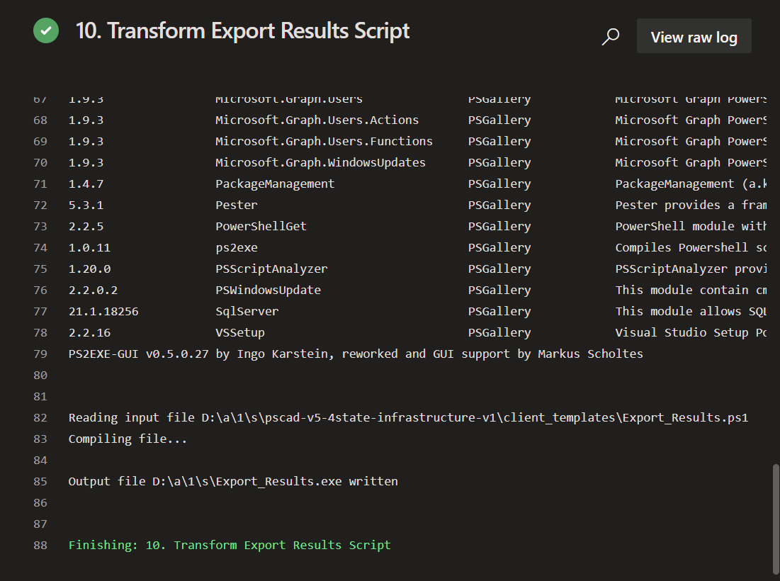

11. Transform Export Model Script

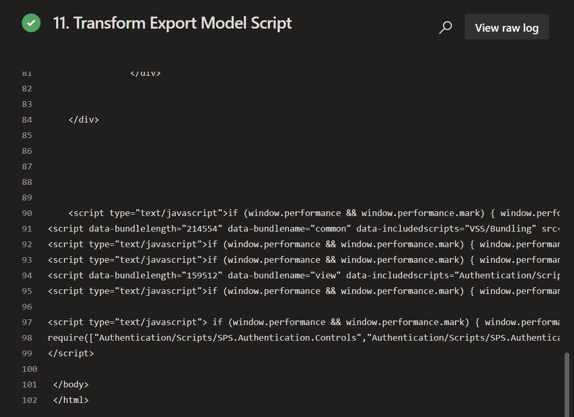

12. Transform PSCAD Install Script - Client

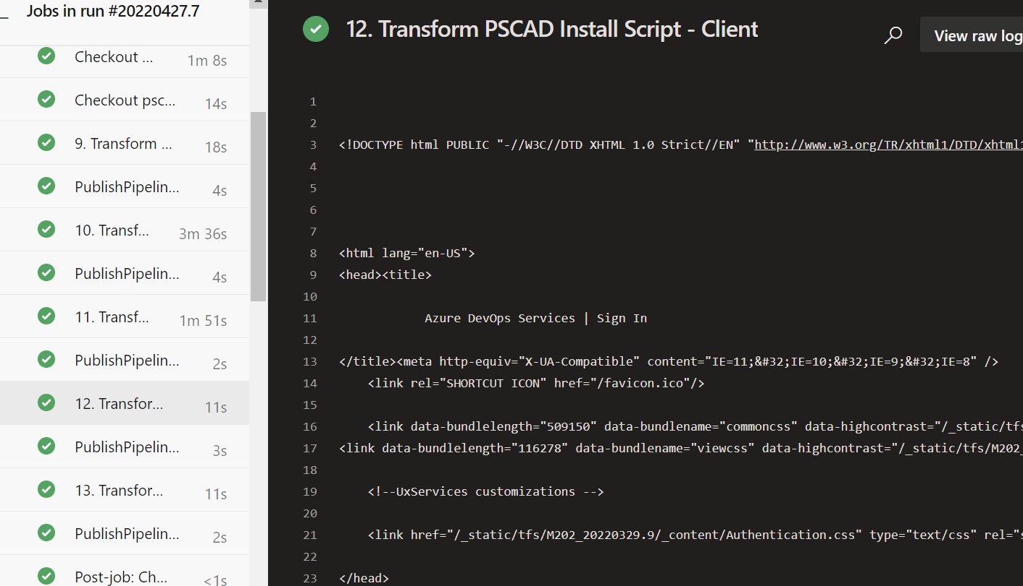

13. Transform PSCAD Install Script – Master

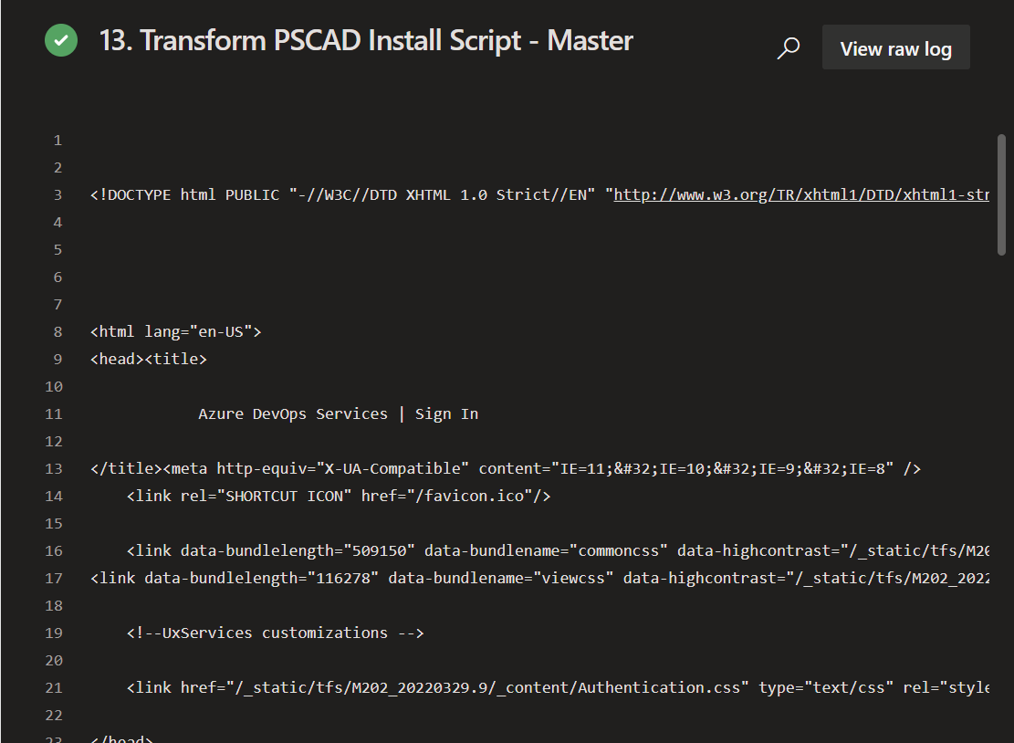

**Deploy_Model**

14. Deploy Master Specific Model - Blob Transfer

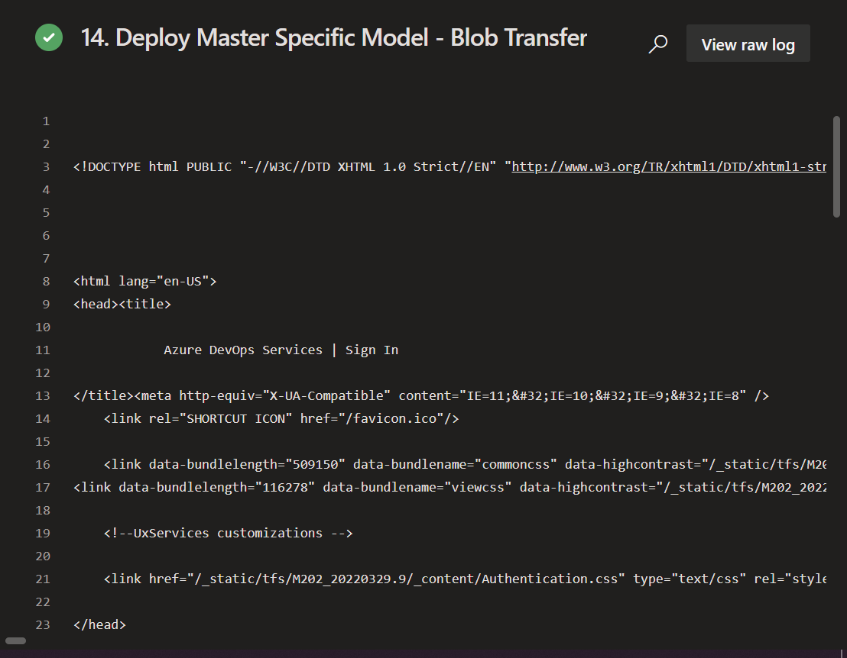

15.

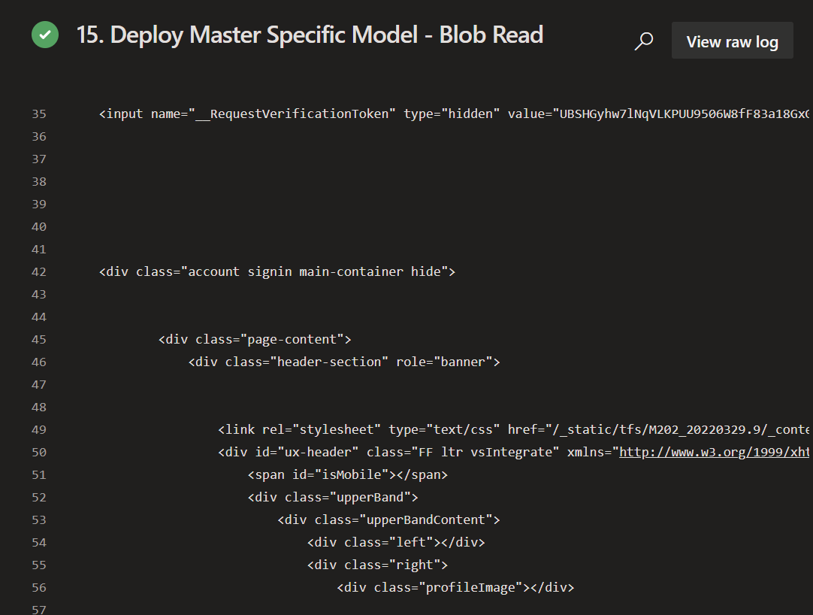

16.

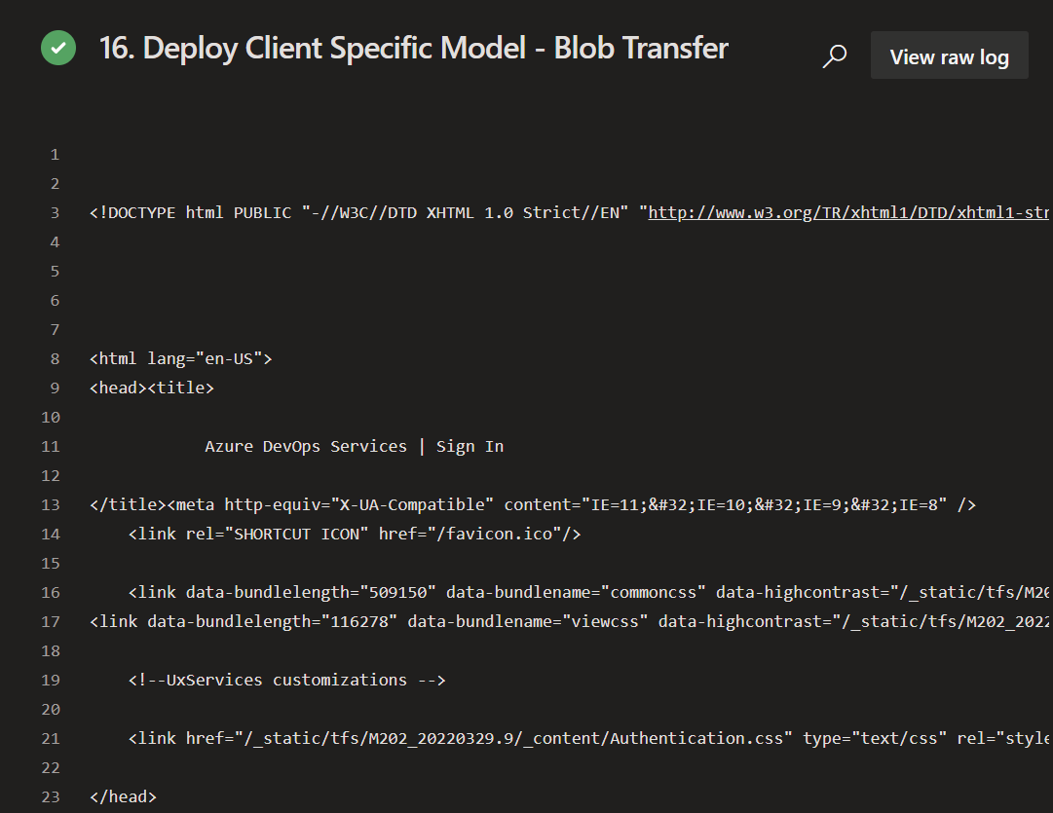

17.

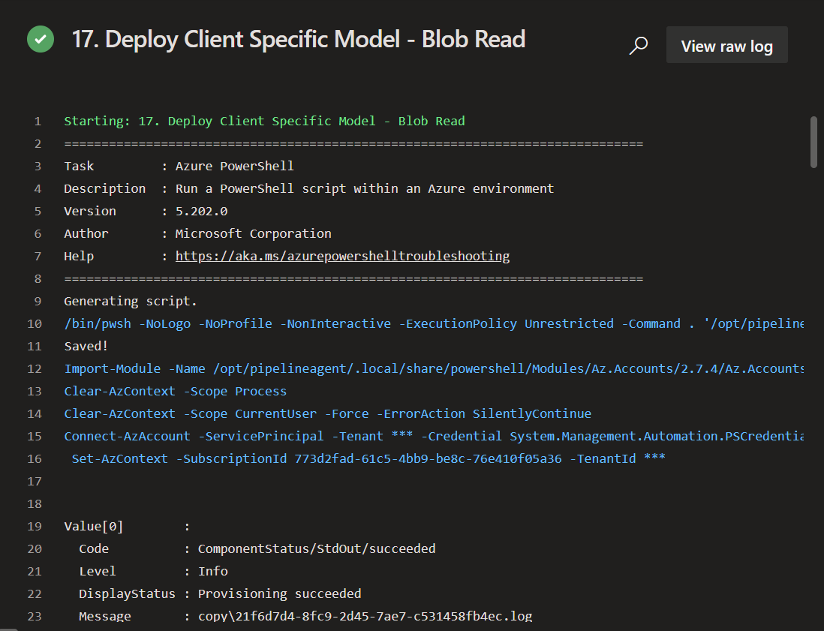

**Install_Plotting_Tool**

**Install_Myrtille_On_Jump**

**

**

**

**PSCAD_License_Start_Clean**

**

**

**Start_Initiate_Automation_On_Master**

Initiate Automation on Master - Execute run_Master.bat

**Database**

**

**

33.



